* 

Career Planning: Getting Started



# Career Planning: Getting Started

## Contents

* Planning your career
* I have no idea what I want to do
* I have a few vague ideas….. Insert your choice of statement here
* There’s just too much information out there / I know what I want but don’t know how to get there
* I want somebody to tell me what to do
* Employability
* Useful websites
* Suggested reading

# 

## Planning your career

Thinking about what you want to do when you complete your degree can seem overwhelming; it can feel like a big decision, a kind of, ‘what am I going to do for the rest of my life’ kind of moment. As with most big decisions they become easier if you break things down into some more manageable and achievable steps. Let’s look at where you are now. When you think about your career, which of these statements best describes you?

* I have no ideas about what I want to do
* I have a few vague ideas but….
* There’s too much information out there - I think I know what I want to do then I discover something else that gives me fresh ideas.
* I know what I want to do but don’t know how to get there.
* I want someone to tell me what to do.

Which option did you pick as being closest to how you’re feeling right now?

For each of the points above, this guide will provide starting points for you to consider when thinking,

about your longer-term career plan.

## I have no idea what I want to do

Flipping this around, feeling that you currently have no ideas at all is not necessarily a bad place to be. It means that in theory at least, your options are unlimited. You may also find the reality is that you are likely to have a better idea about what you ***don’t*** want than what you do want. So how do you narrow things down a little to make exploring your options easier? Here are some ways that you could do this:

## Understand what makes you tick!

This means doing some thinking about what you are looking for from your career:

* + Do you want to do work that is personally meaningful to you in some way?
  + Do you see yourself fitting into a corporate environment or not?
  + Would you like to be creative or innovative in some way?
  + What about sales – comfortable with that or not?
  + Are you looking for something that will provide a challenge – what kind of challenge?
  + Where do you want to work?
  + How important is money?
  + Do you want to change the world?
  + Do you want a job that has the potential for travel?
  + Would you prefer to work for yourself or have your own business?

Another question to consider is ‘If you could do anything, and there were absolutely no barriers to you doing it, what would you do’? This might just give you some strong clues as to where your interest and motivation lies.

These might be tricky questions to answer but giving them some thought can begin to provide you with some pointers to where you might fit within the working world.

It can be difficult to do this on your own, so why not make an appointment to see one of our experienced Careers Advisers and get them to ask you the questions? Sitting down with a Careers Adviser might be all you need to become more focused in terms of your career thinking.

Appointments can be made online via <https://myadvantage.salford.ac.uk/students/appointments/>

### Career questions

If you prefer a more structured approach to help you think about your options, you can do this by using some career questionnaires. This can provide you with some ideas to explore further, an easily accessible one is:

* + - [Prospects Career Planner](http://www.prospects.ac.uk/myprospects_planner_login.htm)

This tool looks at interests, skills and motivations and, depending on your answers to the questions, will generate a list of suggestions. Some of these suggestions will be a stronger match, others less so, the important point here is that they are simply suggestions. The questionnaire will not tell you what you should do, or what your ideal career will be. What they will do though, is provide you with starting points for further exploration and a little food for thought. A key piece of advice is to take your time completing these types of quizzes. It’s tempting to rush through them to see the results but the process of thinking about the questions can be just as valuable in helping you realise interests and preferences you might not have considered before.

### Options with your degree

Another option is to explore jobs and careers which relate to your subject of study. Prospects have a helpful [Options with Your Degree](https://www.prospects.ac.uk/careers-advice/what-can-i-do-with-my-degree) on their website. Simply find your subject and start exploring the profiles of the jobs that are listed. Keep in mind that this isn’t a definitive list of everything you might do as a career, but it’s a great way to start considering some possibilities.

### Careers Fairs or industry insight talks

Attend careers events such as careers fairs or industry insight talks. This allows you to meet and speak to people directly about their job, career and where they work. They can give you honest and realistic insights onto working in their sector. This can be very useful in helping you consider whether what they tell you is interesting and something you want to explore further. [Advantage](https://www.salford.ac.uk/careers/support/using-advantage) is a good place to find details of fairs and events you can attend.

## I have a few vague ideas… insert your choice of statement here!

If you already have some ideas, no matter how vague, a positive step would be to find out more.

Here are some resources that can help you to become more informed:

### Job profiles on the Prospects website

[Prospects - Types of Jobs](http://www.prospects.ac.uk/types_of_jobs.htm) are a really useful resource and will provide you with a detailed job profile covering what the job involves, usual entry requirements, salary indications, who employs people doing the job and where you can find vacancies. A really great feature and one that can get missed is the link to ‘Related jobs’ – useful for broadening your ideas out a little!

Similar, but not quite as detailed, are the [TARGETjobs](https://targetjobs.co.uk/careers-advice/job-descriptions) profiles.

You can also view videos of people talking about their jobs at [icould.com](http://icould.com/)

### Talk to people doing the job

This can be a great way to find out more about a job or career that you are exploring. Generally speaking, most people will be happy to talk to you about what they do – the good points and the not so good! Remember the view and opinion you get will be theirs, it’s up to you how you use the information. If you have family or friends working in the area, then this is a good starting place to start considering who you could talk to.

### Get some experience

It sounds obvious, but getting some experience related to the area of work that interests you can be a great way to learn more and confirm if pursuing a career in that industry is something you want to consider. You can search for part-time jobs, placements, internships, and voluntary work through [Handshake](https://www.salford.ac.uk/careers/support/use-our-vacancy-portal).

## There’s just too much information out there / I know what I want but don’t know how to get there

The internet can be overwhelming in terms of the amount of information that can be accessed. This can make it difficult to focus in on information that is important. It makes sense to narrow your reading down to a small number of credible websites. Prospects and TARGETjobs are good starting points; professional bodies and associations are strong, credible sources of information. There are other sites and links that will provide you with the information you need to know. These can be found on the [Career Planning](https://www.salford.ac.uk/careers/career-planning/) section of our website.

## I want somebody to tell me what to do

No-one can! Deciding what you want to do after your degree can be a challenge but any decisions that you make must be your own. It is important to recognise that there are a lot of resources and support available to help you. Don’t put it off until your final year, make use of the services provided by Careers & Enterprise Team or through your course and use these to help you make your own decision.

It’s important to understand that the world of work and careers is changing rapidly and becoming much more flexible. It is becoming the norm that people will, and already do change their careers several times over a working lifetime. The decisions you make now may well influence what you do longer term, but this doesn’t mean that you will be doing the same thing for the rest of your life.

## Employability

Employability refers to the skills, knowledge, behaviors and experience you will gain during your time at university, through studies and work experience, that will enable you to keep learning and developing through your career.

Developing your employability will also mean that you will be more likely to gain and sustain employment in the future. Subject knowledge can date but the skills you gain and the capacity for learning will remain.

Employability or transferrable skills are the core skills and attributes needed in almost all graduate jobs. Some skill requirements will be job specific but many of the desired skills will be 'general' or 'soft' skills that you gain from academic and other life experiences. They are also vital if you are going to be self-employed, for engaging with potential investors and customers. The good news is, much of the ordinary, everyday activity that you undertake as a student can help you develop your employability skills.

### Salford Employability Skills

From our own labour market research, we have identified [ten employability skills](https://www.salford.ac.uk/careers/career-planning/employability-skills) most valued by employers across many different sectors. Whatever you are studying you'll develop many of these skills through your course, and the more you get involved with the many opportunities on offer at Salford, the more you will enhance your employability.

Explore each of the skills shown below and think about which ones you already have, which are most relevant to your possible future career, and how you can identify, develop and demonstrate them.

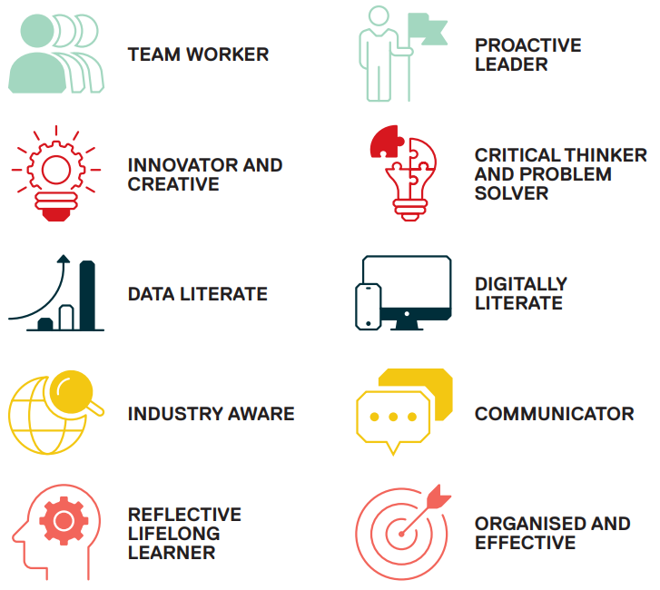

Recruiters will ask for evidence of these skills. Being able to identify when, where and how you developed certain transferable skills and competencies will assist you when thinking about possible career pathways. Each occupation will have specific requirements in terms of knowledge and skills and understanding; what you are good at and what skills you enjoy using will help you to understand how potentially you could meet the criteria and in turn help you to confirm the career decisions you are making.

So, there you have it, a quick guide to getting started with your career planning. The key thing to remember is to break a big question down into more manageable parts. Hopefully, this guide will have helped you to approach this with some confidence and in a more planned way than would otherwise be the case.

Good luck and don’t forget that Careers & Enterprise Team can support you every step of the way.

## Useful websites

[Prospects - A long](http://www.prospects.ac.uk/) established student and graduate careers website - lots of resources including a career planner, job profiles and the section ‘what can I

do with my degree’ – also advertises graduate jobs, both graduate schemes and direct entry positions.

[TargetJobs](http://www.targetjobs.co.uk/) - A student/graduate website offering the same range of information as Prospects. The profiles are not as detailed.

[National Careers Service](https://nationalcareersservice.direct.gov.uk/) - A comprehensive database of job profile though not aimed at graduates specifically.

[Insidecareers - Co](http://www.insidecareers.co.uk/)ncentrates on providing very detailed information around careers such as Accountancy, Management Consultancy, Banking, IT, Patent Attorney and Tax to name a few.

[What Do Graduates Do?](https://luminate.prospects.ac.uk/what-do-graduates-do?utm_source=hecsu.ac.uk&utm_medium=referral&utm_campaign=redirect) - Produced annually, ‘What do Graduates do?’ tells you what students studying your degree were doing six months after graduation.

[http://www.porot.com -](http://www.porot.com/en) A guide to career management incorporating some self- assessment tools that could be useful in terms of career choice.

## Suggested reading (available in the Library)

## Brilliant Graduate Career Handbook - By Judith Done (e-Book only)

A guide for undergraduates to help them consider what to do with their degree once they have graduated. This book has information on how to navigate the labour market, how to keep going when the going gets tough and how to make best use of available opportunities.

## The Art of Building Windmills - Career Tactics for the 21st Century By Dr Peter Hawkins

A comprehensive book which gives information on how people can take control of and manage their own personal career planning and career development.

## What Colour Is Your Parachute? - By Richard Nelson Bolles

A practical manual for job-hunters and career changers. A long-standing guide that is updated annually, an excellent resource.

## The Graduate Career Guidebook - By Steve Rook

A practical guidebook to finding the best job for you – for any student or graduate.

# Updated August 2023